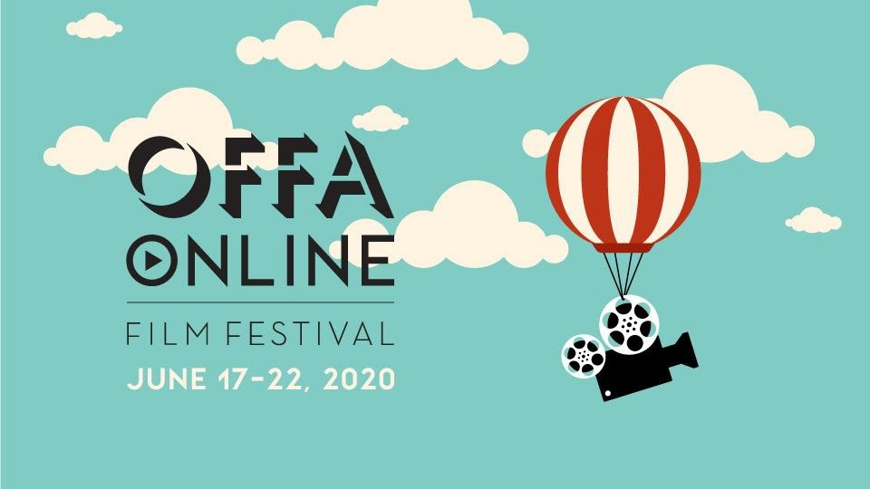

For Immediate Release:

And the Awards go to…

OFFA Online 2020 Award Winners
Oakville Festivals of Film and Art is thrilled to announce its OFFA Online Award Winners for the Juried 2020 Festival ! This was an exciting year, and the Jury had a very difficult time picking the winners due to the outstanding quality of the over 65 films screened digitally at the festival.
Winner Best feature or documentary film - From the Vine Director Sean Cisterna
Sean received a cash award of $1500 plus a $1000 gift certificate from William F White
Nominated:
Queen of the Morning Calm Dir. Gloria Kim
The Great Disconnect Dir. Tamer Soliman
Winner: Best Canadian Short film - Our Home Director Andy Alvarez
Andy Alvarez (Red Slide Pictures) received $750 cash prize and $1000 gift certificate from William F White
Nominated:
Father by Law – Dir. Maria De Sanctis
The Butterfly Affect – Dir. Stephanie Blakey
Winner Best international short film - Dia de Las Carpas Director Joao Dall’Stella
Joao received $750 cash prize and $1000 gift certificate from William F White.
Nominated:
Yarne– Dir. Andrew Krakower
Only Death Never Lies- Dir. Sam Yazdanpanna
Congratulations to all of our prize winners, and a huge thank you to all our nominees, who are all truly winners! A huge thank you to everyone who participated in the festival this year. You have all made OFFA Online’s 7th year, and first online festival, an incredible experience for filmmakers our audience, and sponsors.

A BOUT OFFA
Established in 2014, OFFA is a cultural not-for-profit that envisions a community of cultural and artistic diversity with the cinematic arts as a focal point. OFFA produces Oakville’s only independent film festival which is now in its 7th year. For more information on this year’s digital festival, OFFA Online, please visit OFFA.ca.

-end-

